HTML5 & CSS3 Assignment

Aditya Yadav

Learning to code is always exciting and fun for everyone and when it comes to stepping into the programming world most of the people start with the easiest thing [**HTML**](https://www.geeksforgeeks.org/html-tutorials/) and [**CSS**](https://www.geeksforgeeks.org/css-tutorials/). Every beginner’s coding journey in frontend starts with these two basic building blocks and you need to be creative when it comes to designing a beautiful application.

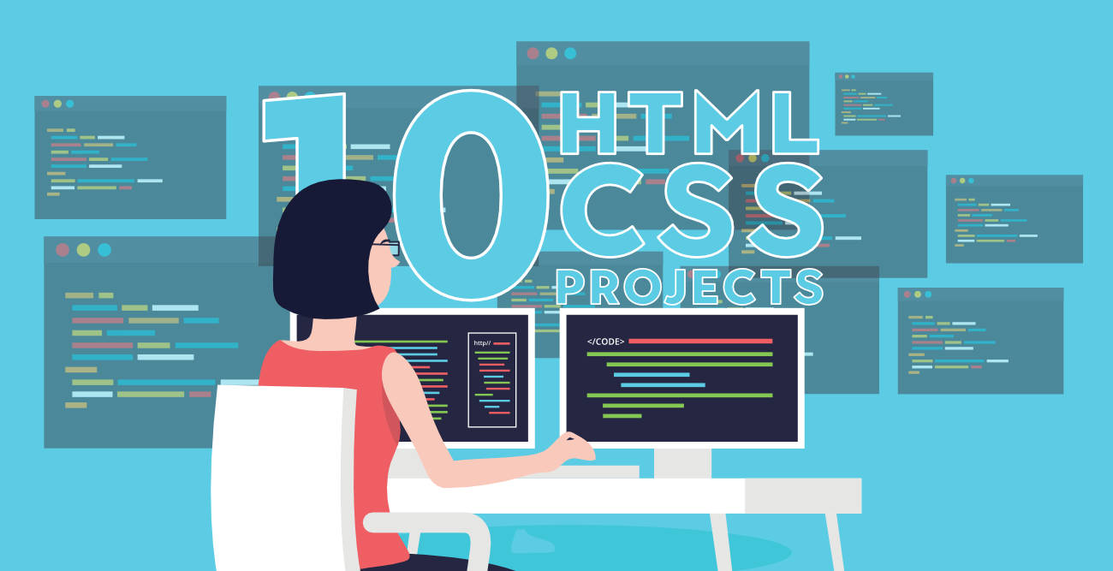

Initially, beginners enjoy making buttons, adding the links, adding images, working with layout and a lot of cool stuff in web designing but when it comes to making a project using only HTML and CSS they get stuck and confuse about what they should make to practice all these stuff. Afterall their knowledge is just limited to HTML and CSS. No matter what after learning everything at some point you will realize that making a project is important to practice HTML and CSS skills. You need to check how HTML and CSS work together to design a beautiful frontend application. So the question is what are some beginner-friendly projects you can build to practice everything you have learned

All Below Project Assignment are Compulsory.

**1. A Tribute Page**

The simplest website you can make as a beginner is a tribute page of someone you admire in your life. It requires only basic knowledge of HTML and CSS. Make a webpage writing about that person adding his/her image. On the top of the webpage, add the image and name of the person and below that give layout for the rest of the details. You can use paragraphs, lists, links, images with CSS to give it a decent look. Add a suitable background color and font style on your webpage. Most of the parts you can make using HTML but to give it a better look using a bit of CSS. Take help from the link given below.

* [My Tribute Page](https://www.codeseek.co/preview/womJzx)
* [Tribute Page to Steve Jobs](https://codepen.io/coderofdark/pen/BzPArk)
* [Tribute Page to Albert Einstein](https://www.codeseek.co/preview/KgWxyq)

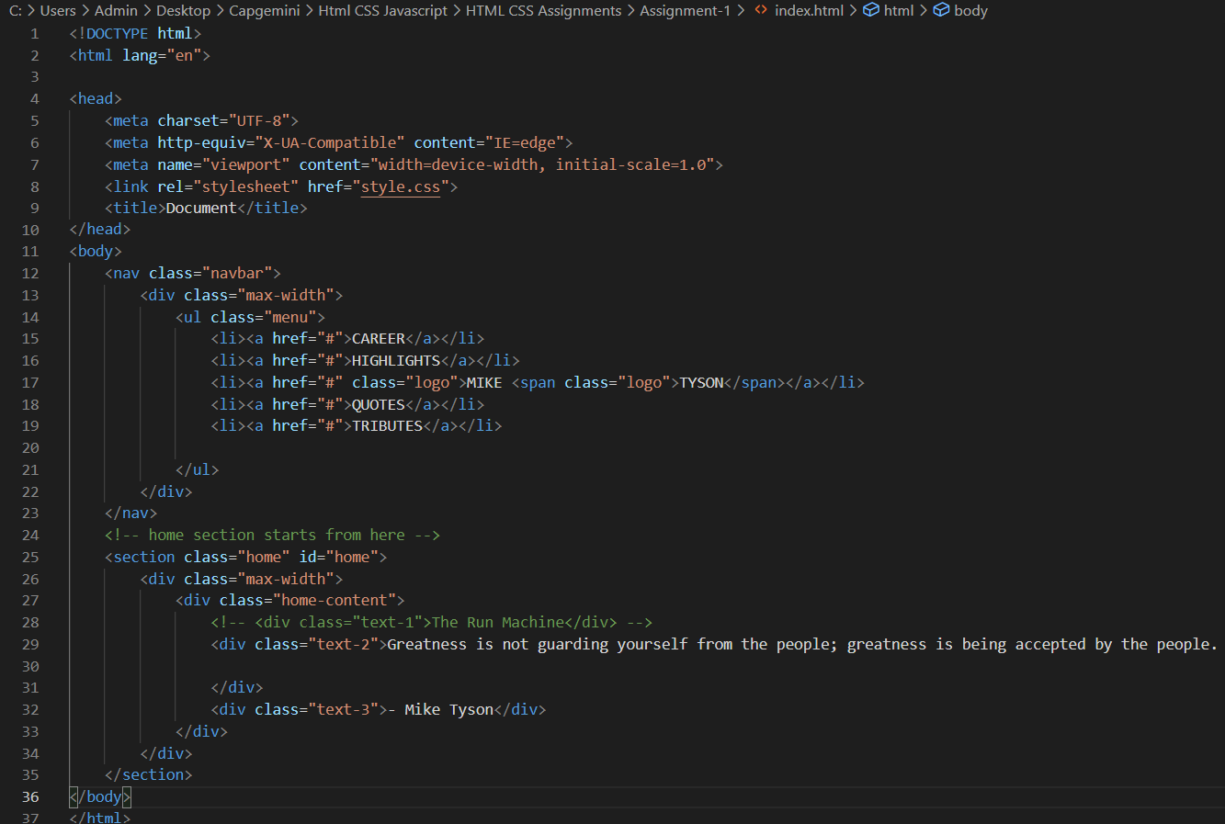

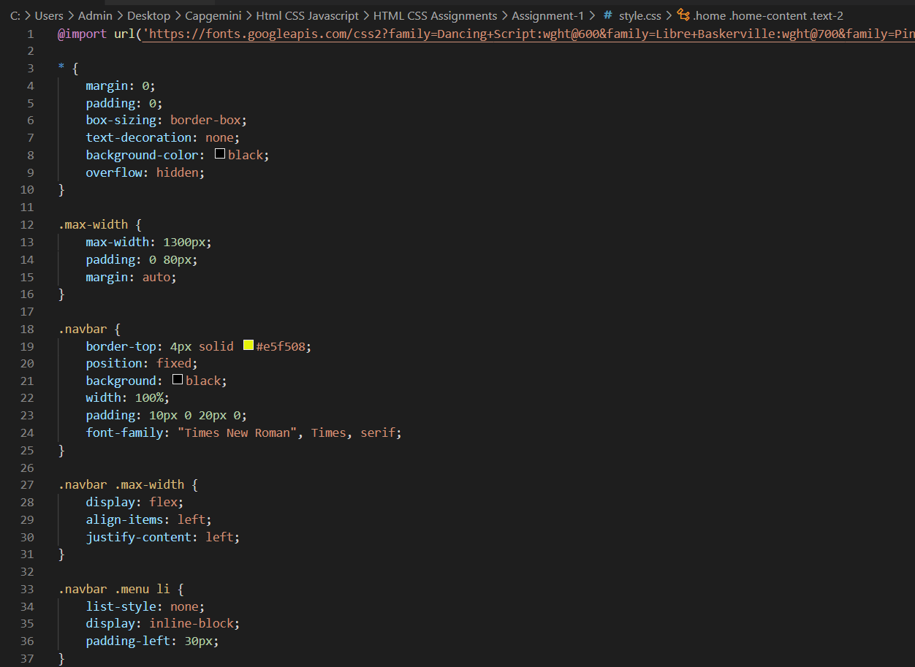

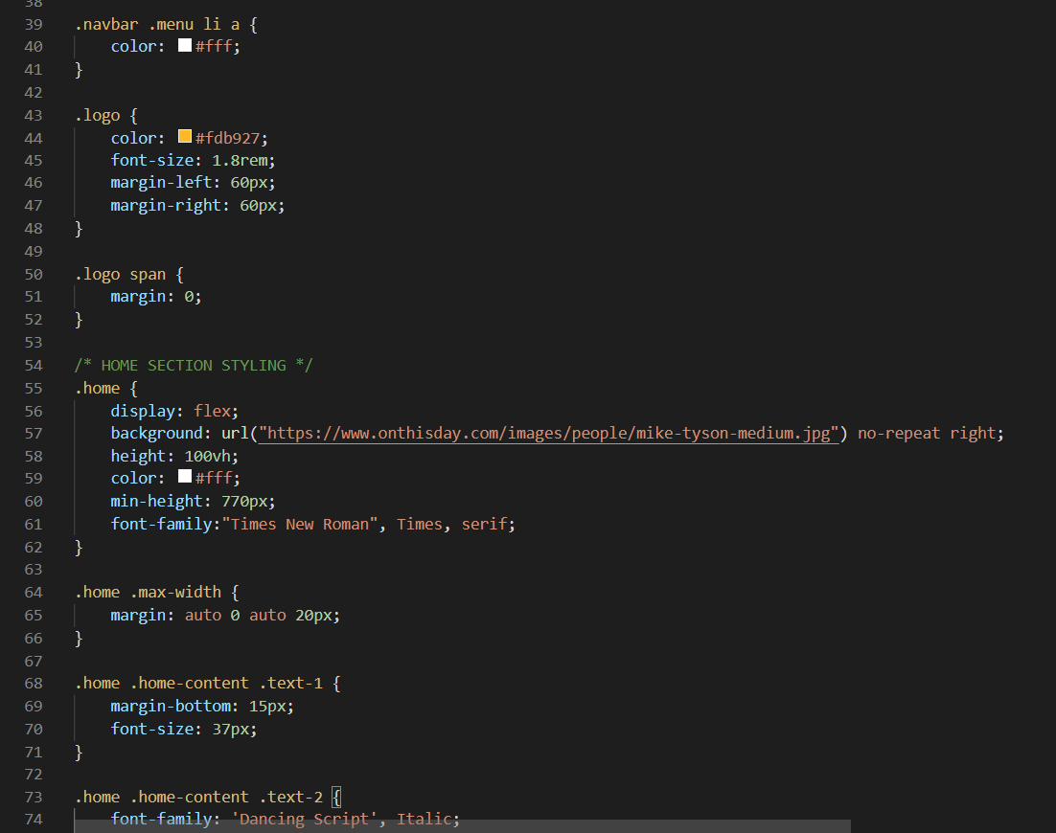

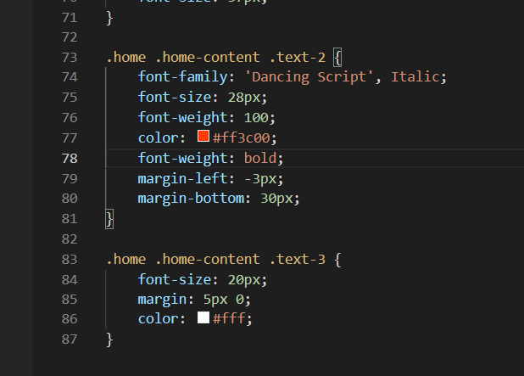

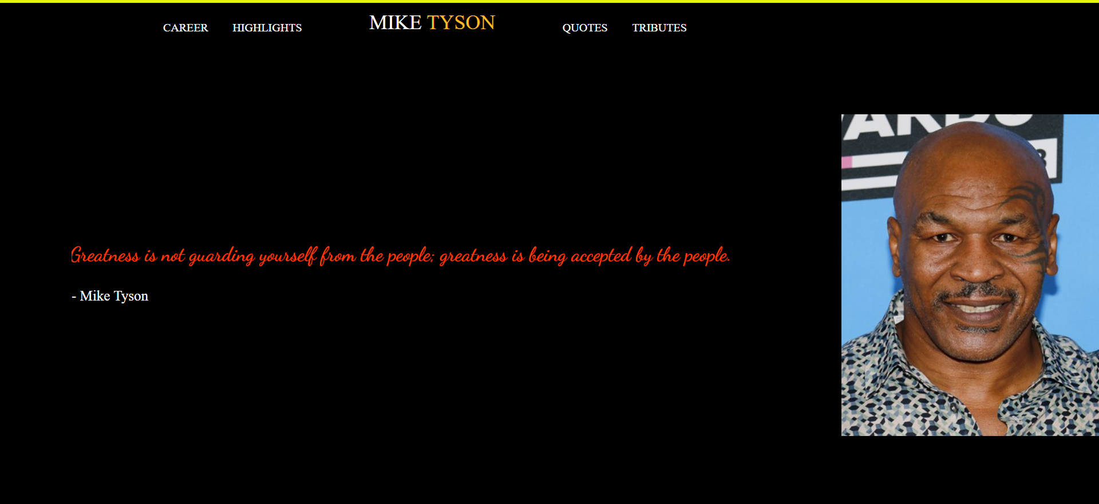

**2. Webpage Including Form**

Forms are always an essential part of any project and you will be working with a lot of forms in most of the applications so why not practice it earlier and test your knowledge. Once you get familiar with the input field or basic tags in HTML to create a form make a project using all those tags. How to use a text field, checkbox, radio button, date, and other important elements in a single form. You will be learning how to give a proper structure to a webpage while creating a form. Knowledge of HTML/[HTML5](https://www.geeksforgeeks.org/html5-introduction/) is good enough but you can use a bit of CSS to make the project look better. Take help from the links given below.

* [Survey Form](https://codepen.io/gregg50/pen/QWwOVKV)
* [Good Vibes Form](https://codepen.io/laurencenairne/full/zLXRPq/)
* [Survey Form](https://codepen.io/freeCodeCamp/full/VPaoNP)

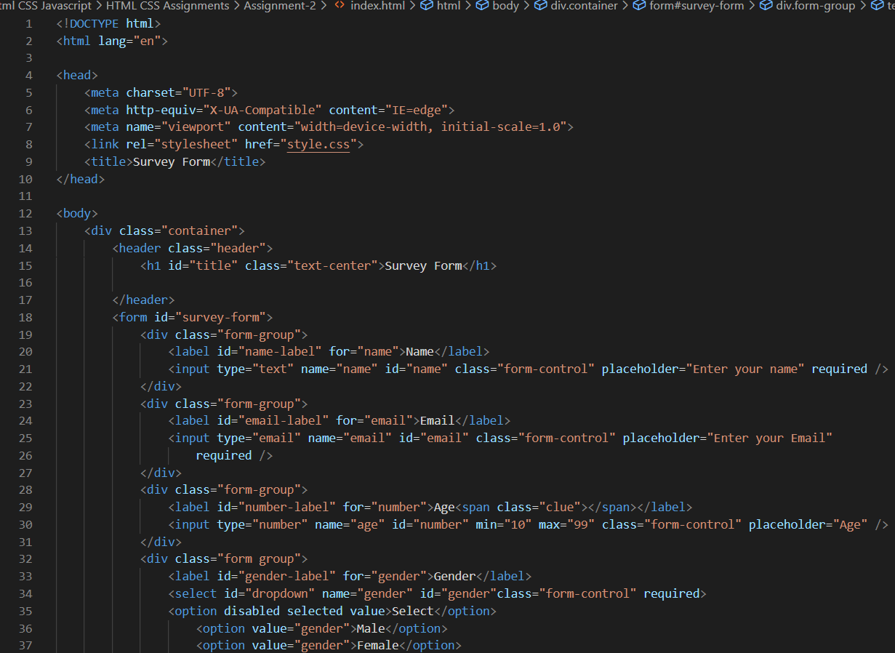

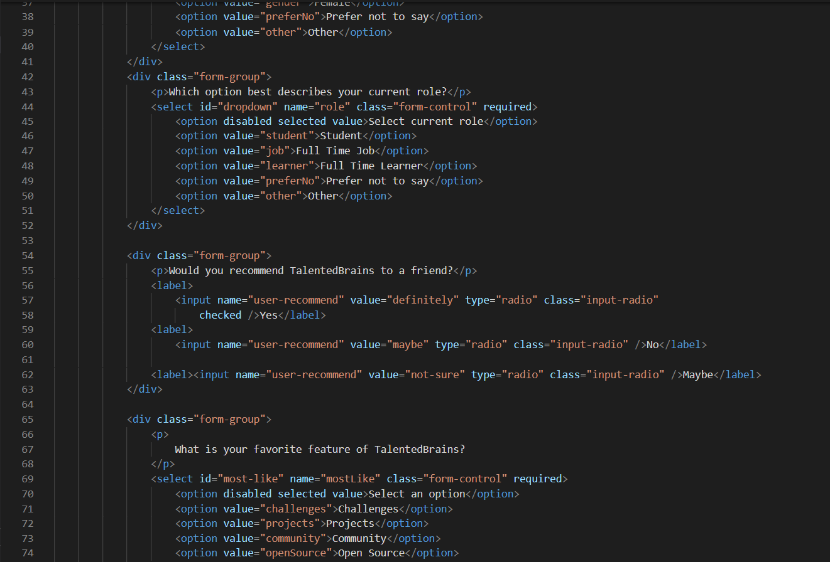

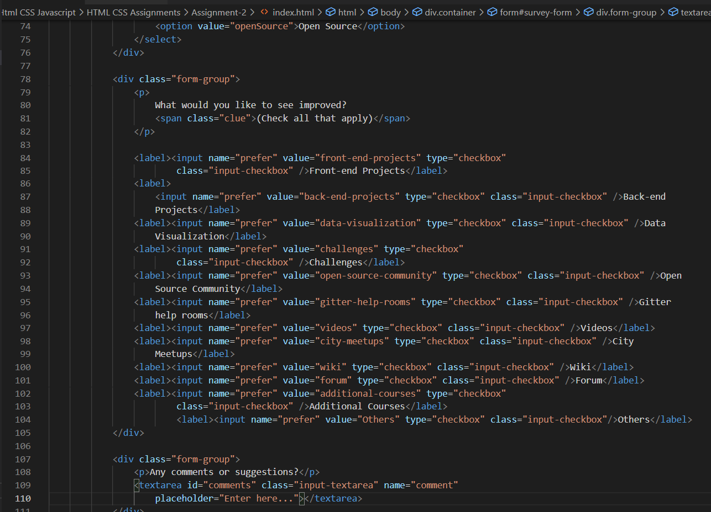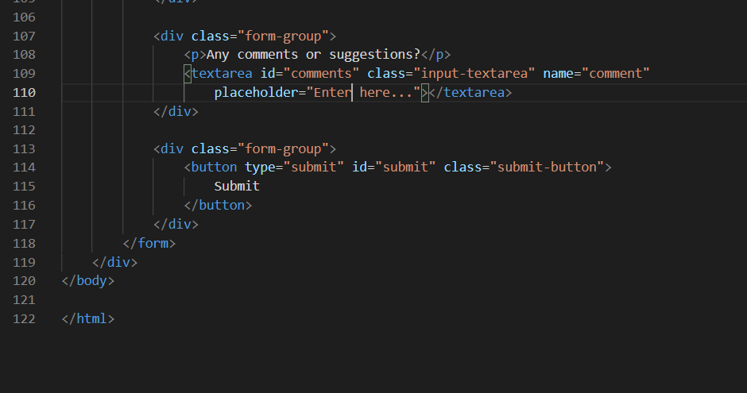

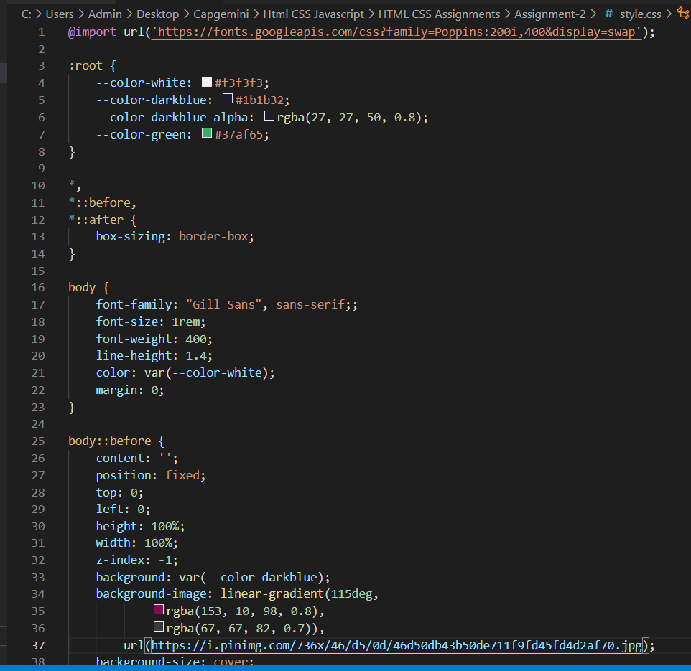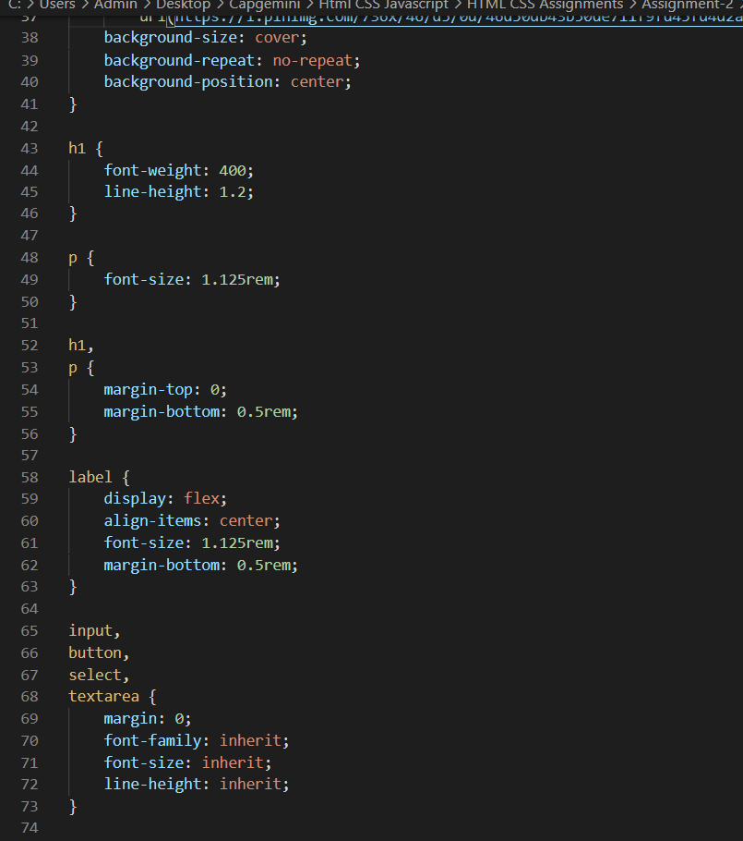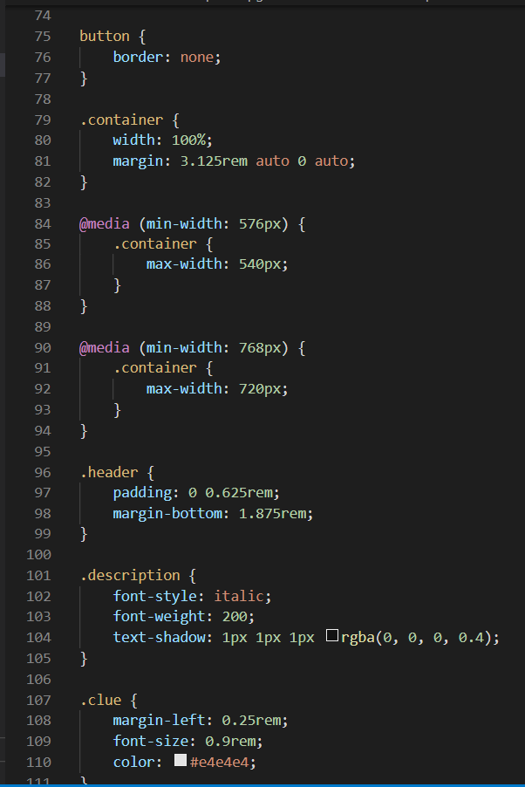

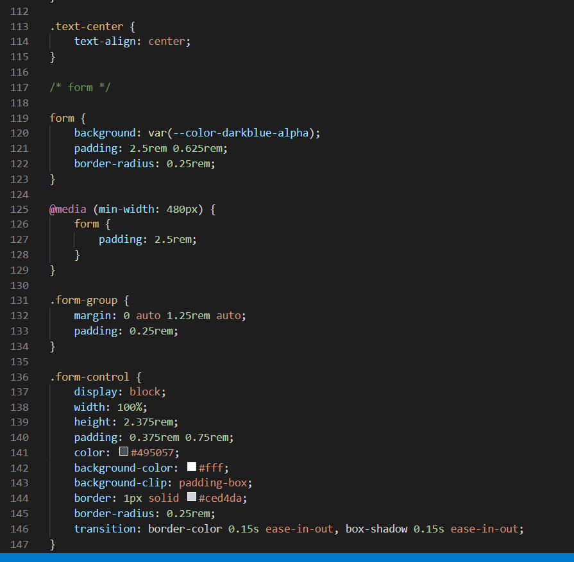

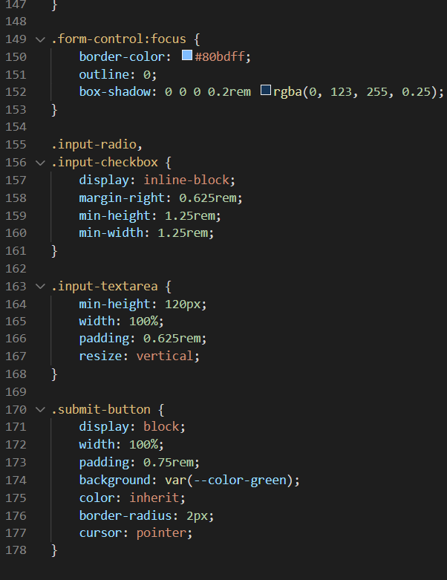

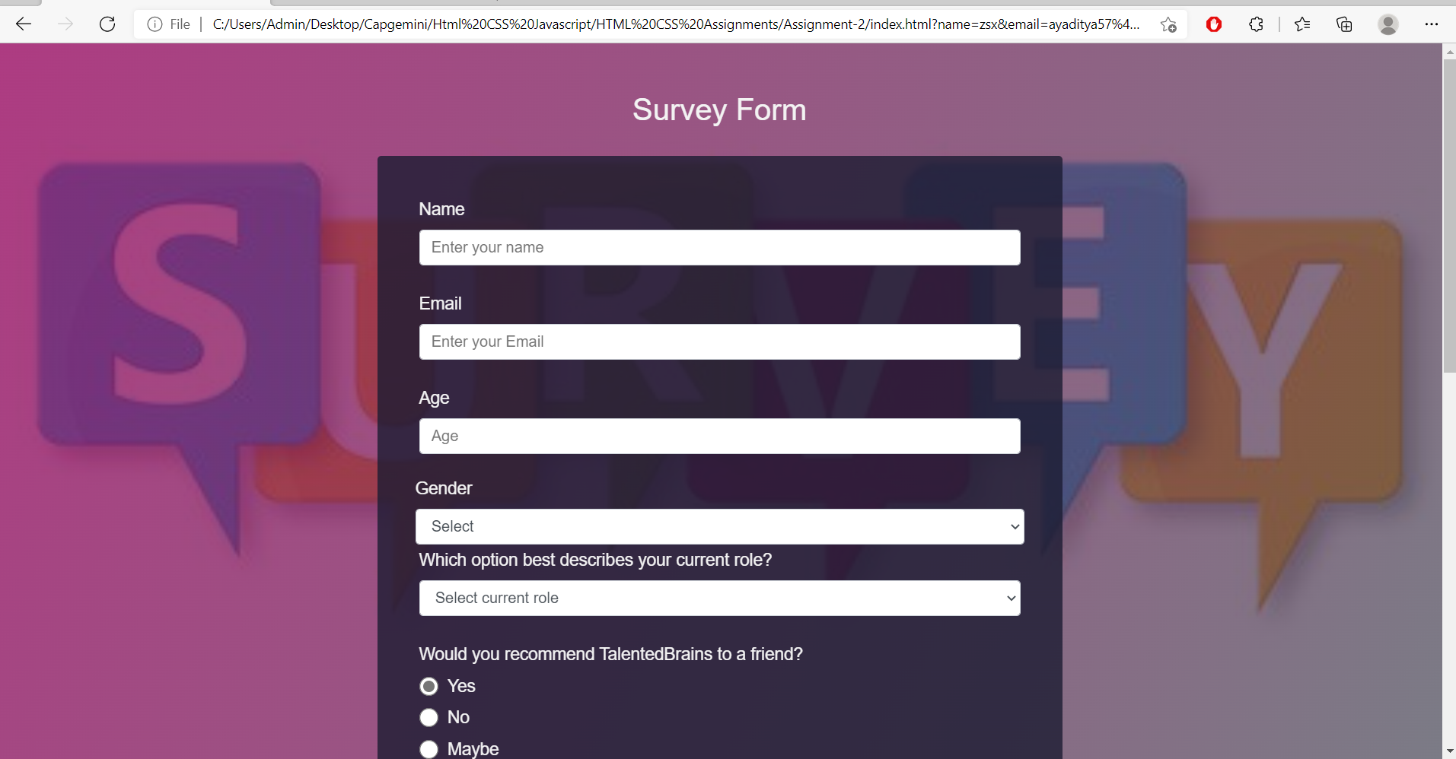

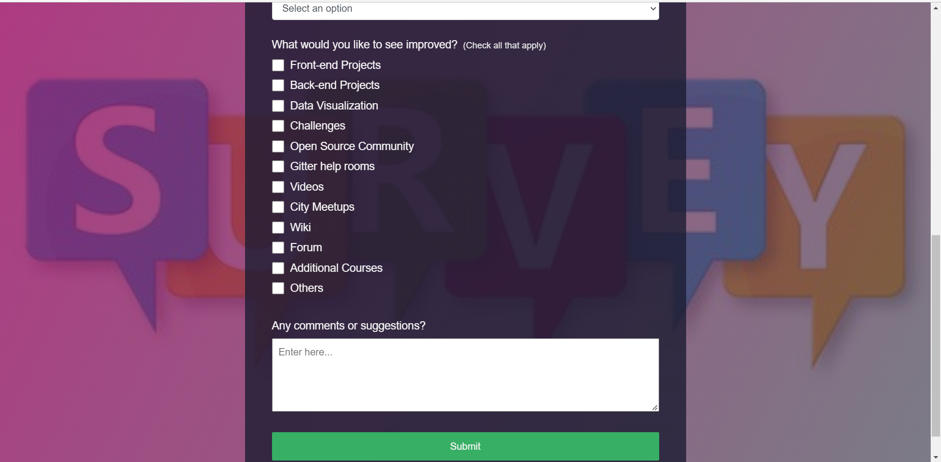

**3. Restaurant Website**

Showcase your solid knowledge of HTML and CSS creating a beautiful webpage for a restaurant. Making a layout for a restaurant will be a bit complicated than previous project examples. You will be aligning the different food items and drinks using a CSS layout grid. You will be adding prices, images and you need to give it a beautiful look and feel as well using the proper combination of colors, font-style and images. You can add pictures gallery for different food items, you can also add sliding images for a better look. Add links for redirection to internal pages. Make it responsive setting a viewport, using media queries and grid. You can take help from [**Restaurant Website**](https://jolly-kalam-23776e.netlify.com/restaurantwebsite/).

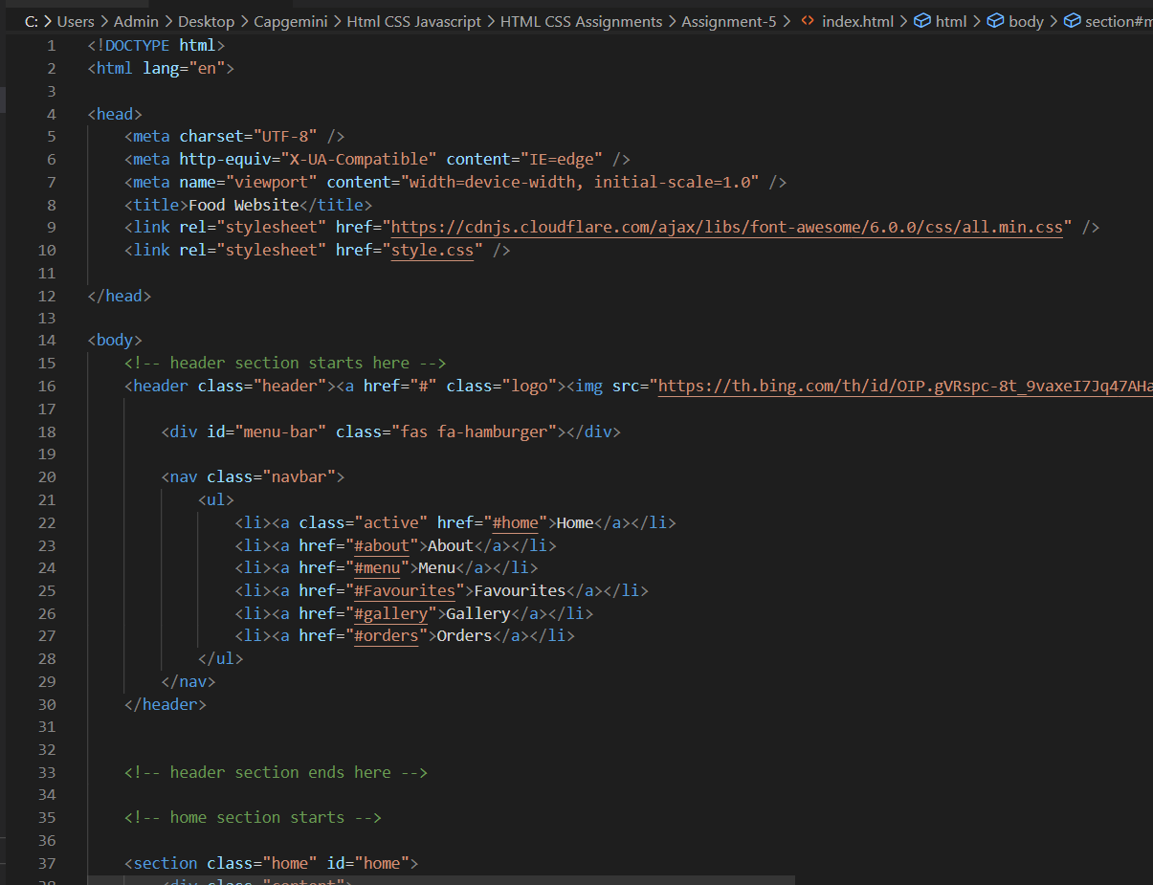

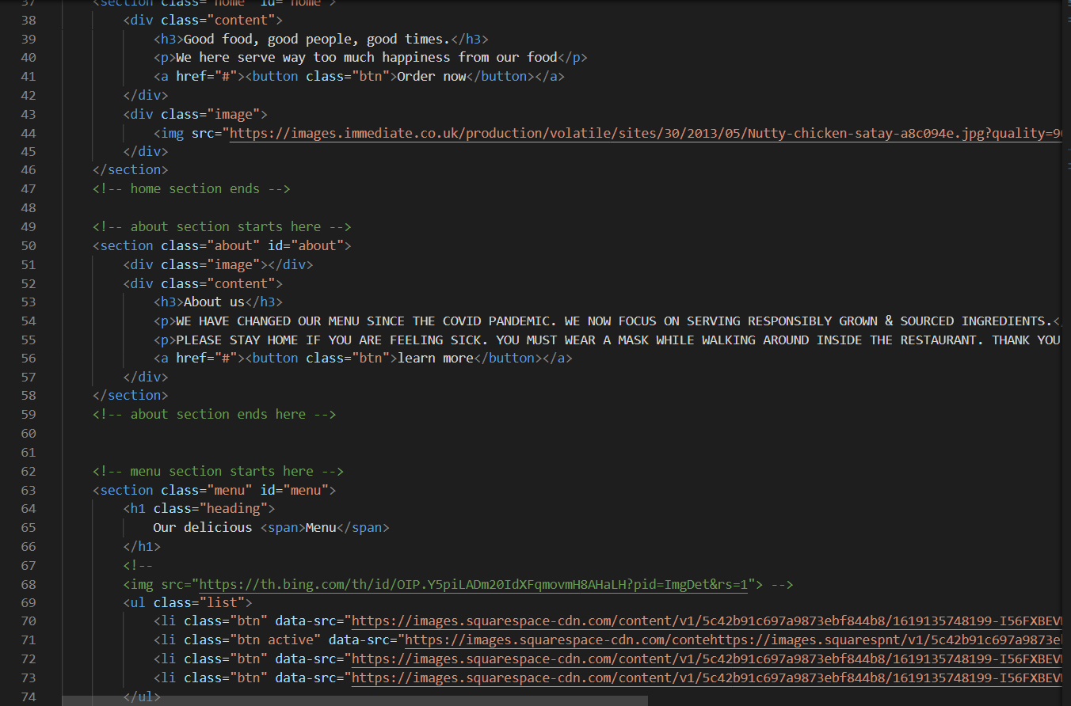

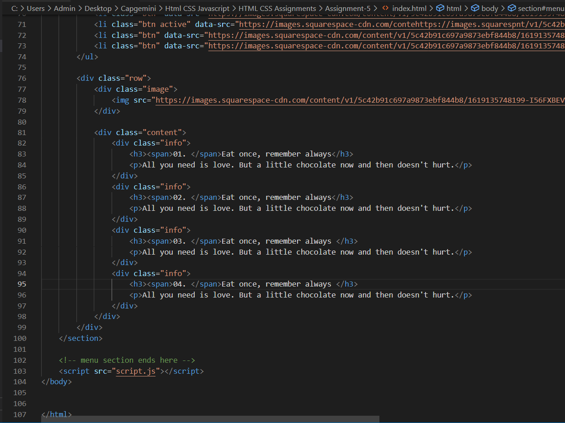

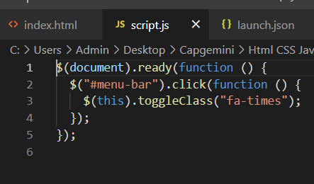

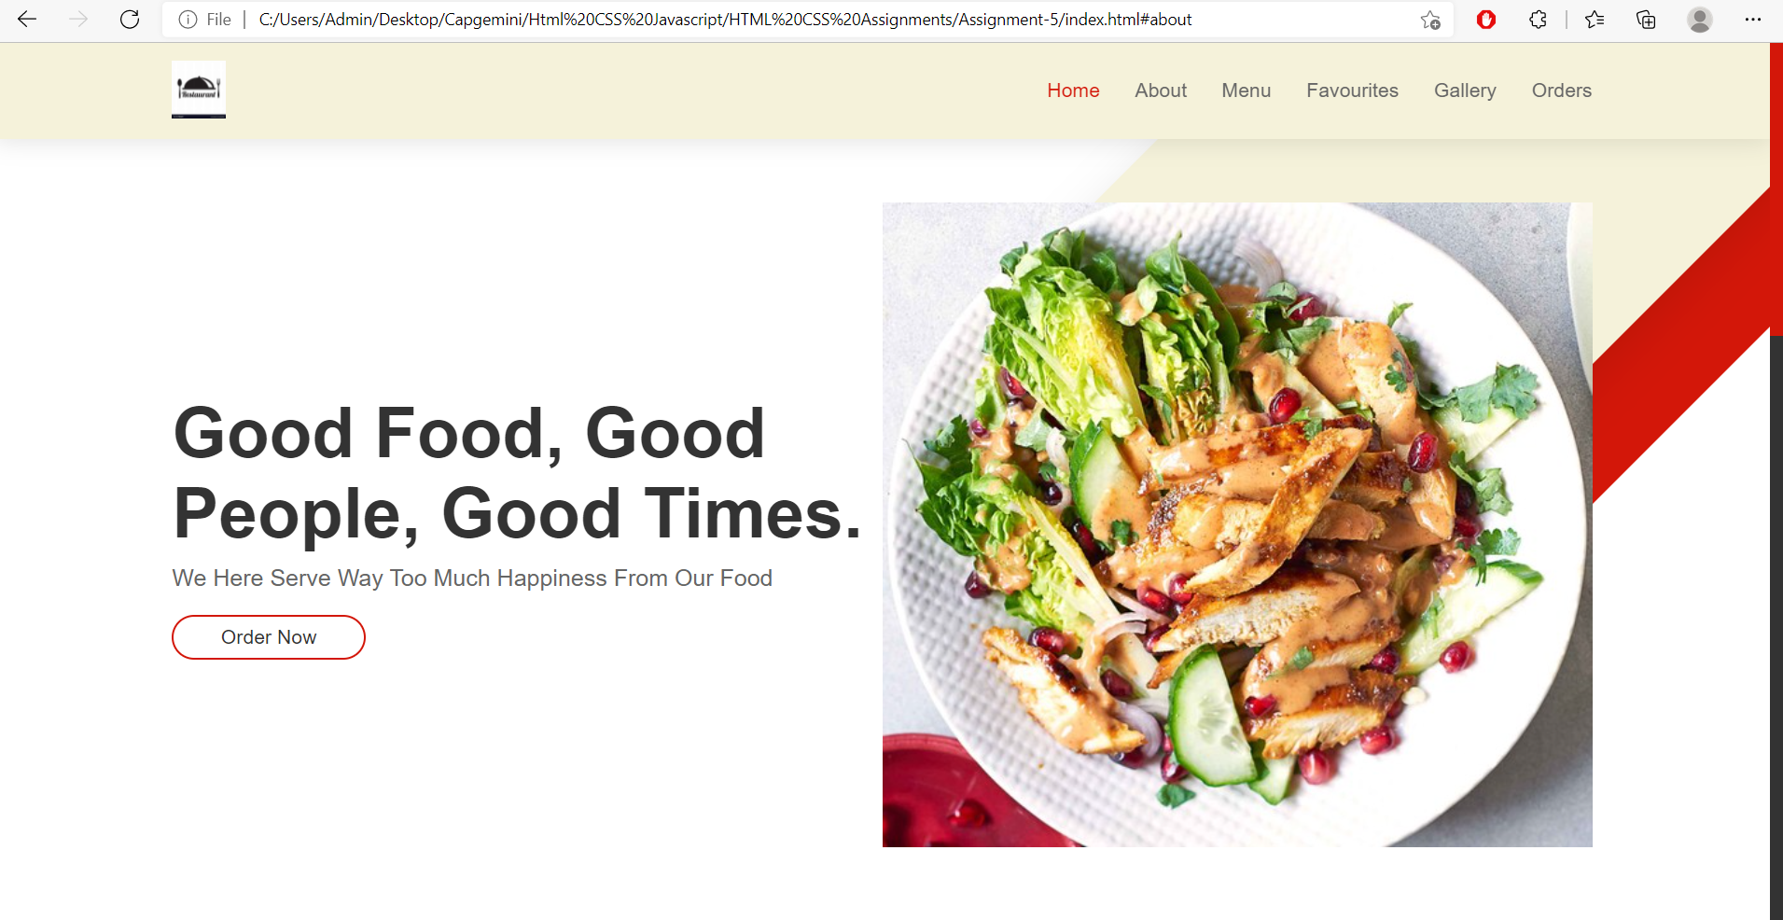

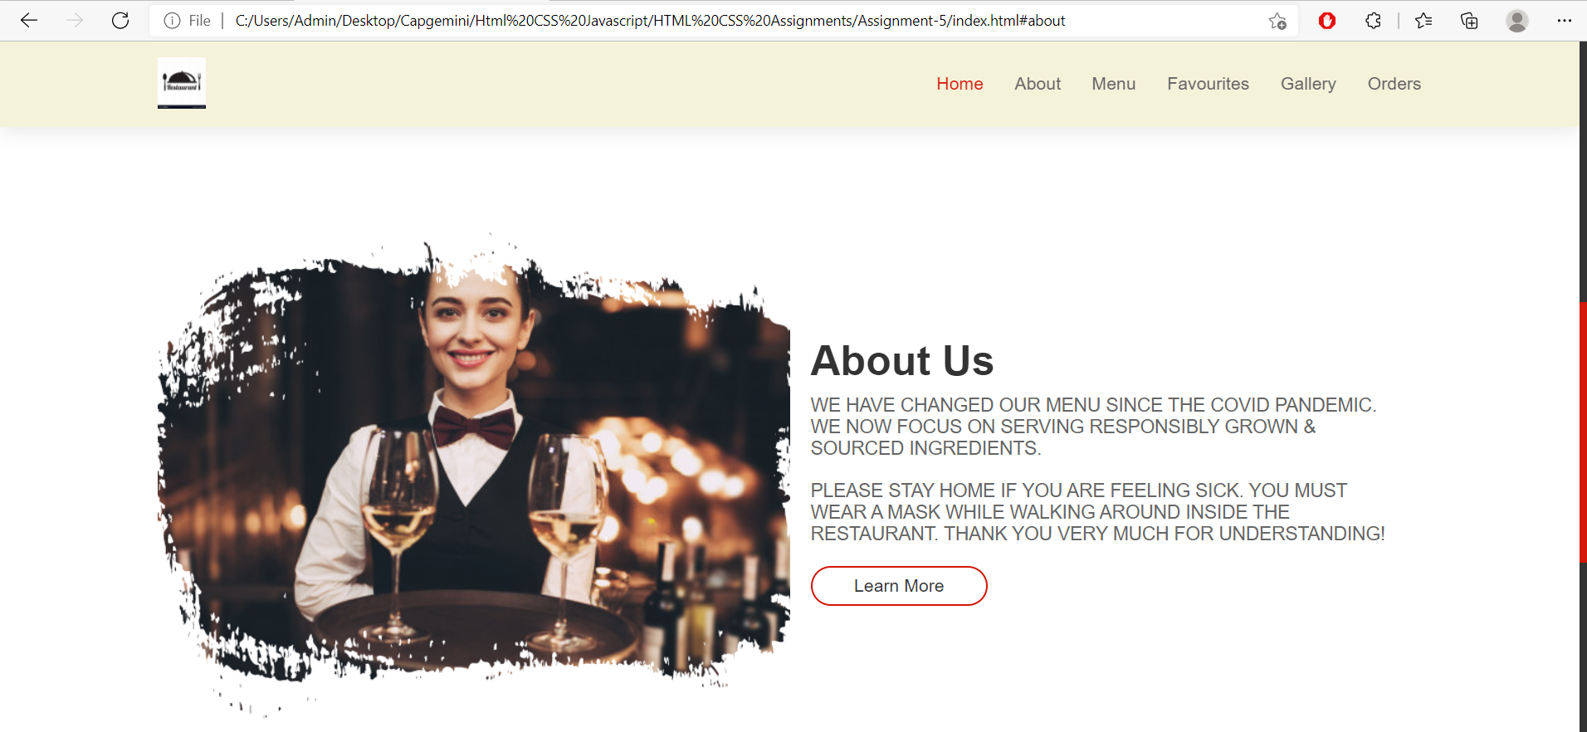

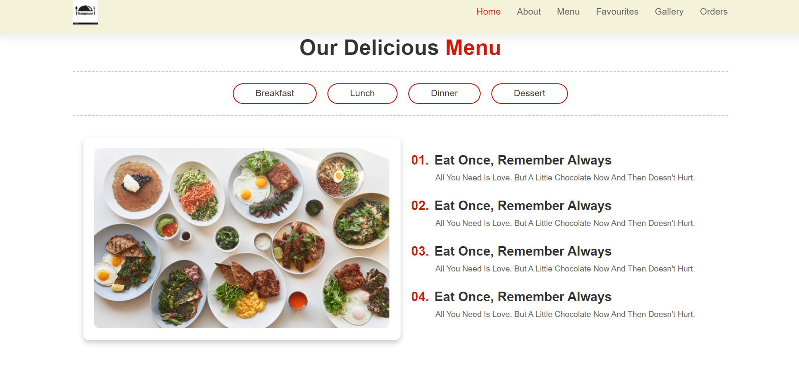

**4. Personal Portfolio**

With knowledge of HTML5 and CSS3, you can also create your portfolio. Showcase your work samples and skills in your portfolio with your name and pictures. You can also add your CV there and host your complete portfolio on [GitHub](https://www.geeksforgeeks.org/how-to-create-and-deploy-your-portfolio-in-under-10-minutes/) account. In your header section mention some menus like about, contact, work or services. At the top add one of your images and introduce yourself there. Below that add some work samples and at last (footer) add contact information or social media account. You can take help from the [**Personal Portfolio**](https://codepen.io/freeCodeCamp/full/zNBOYG).

